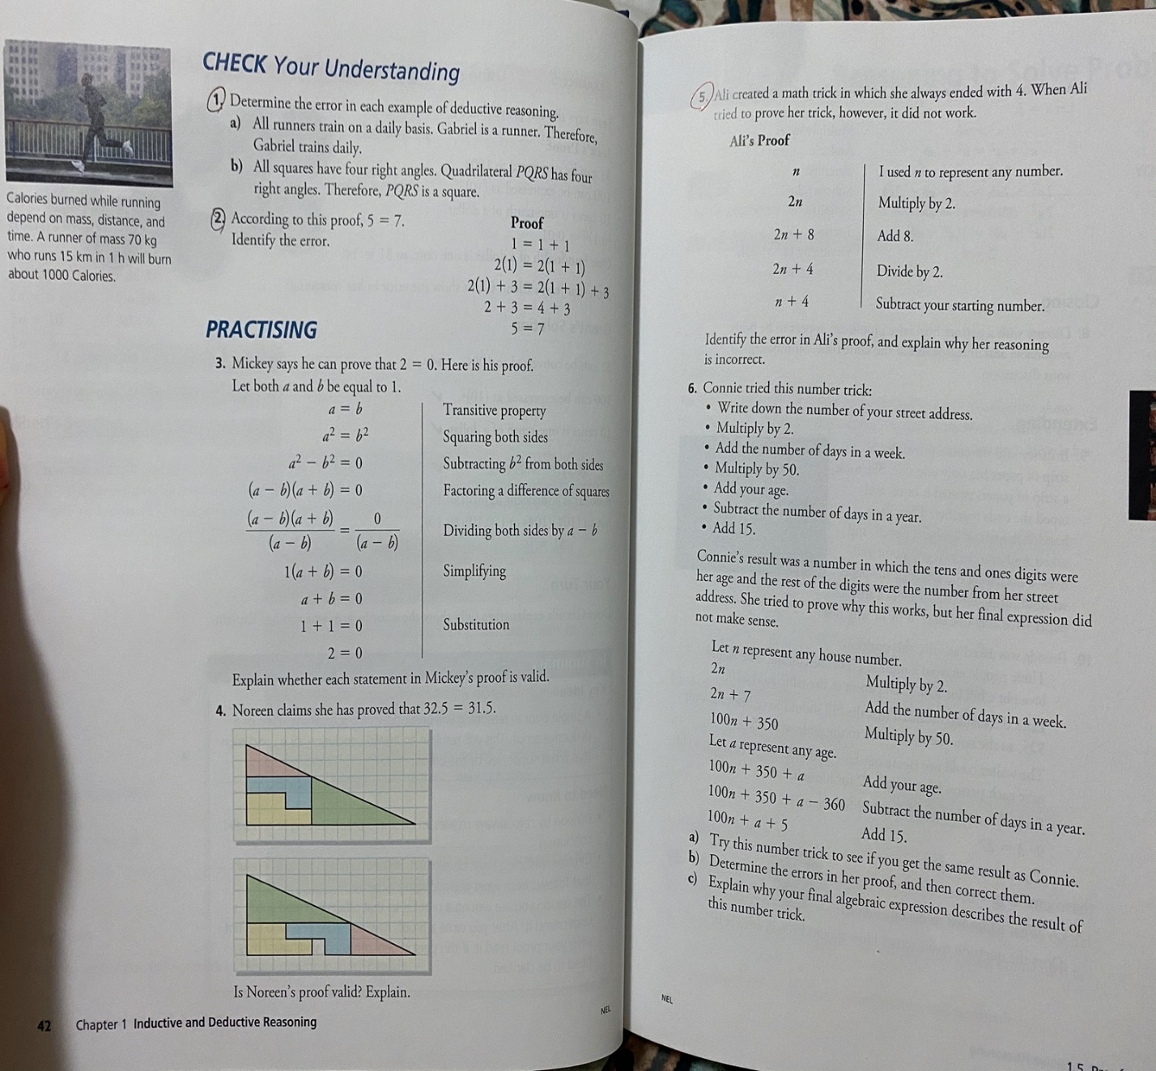

1
- The error to Gabriel’s running on a daily basis is:
The number of hours a day that Gabriel’s runs has not been indicated.
Secondly, Gabriel’s mass is not given.
Finally, the number of kilometers Gabriel runs in a day and the time he takes to cover the distance is not given.

b) The error in assuming that quadrilateral PQRS is a square on the basis that it has four right angles is wrong because a rectangle, also has four right angles.

2. the error is at
1= (1+1)
1+1=2
1-2=-1
The error is 1
5. The error in Ali’s proof is at
2n +4: divide by 2
n + 4: subtract your starting number
He deleted 8 and added 4
It should be
2n +8
Then when you divide by 2
It will be n +4
Then when you subtract by the starting number it is equal to 4
Her reasoning is incorrect because she forgets the final step of subtracting by the initial number.

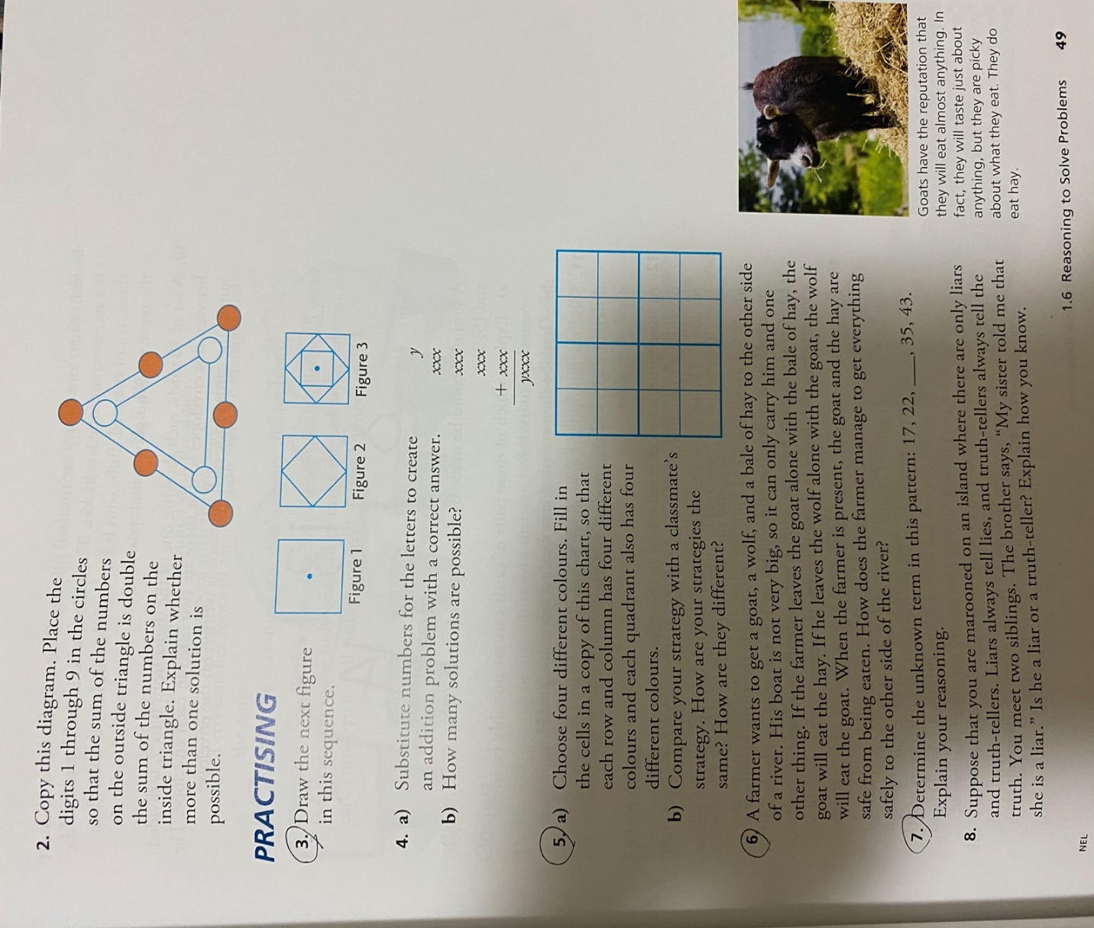
The next figure in the sequence is

5.
My classmate’s strategy is similar to mine because, both our rows and columns have different colors.
Our strategy is different because, we chose different colours to color the cells.
6. first the farmer needs to take the goat to the other side. Then the farmer has to go back for the wolf. After taking the wolf to the other side, he or she has to return with the goat from the initial side where he or she will leave the goat and take the bay of hay to the side that he wolf is. Finally, after taking both the wolf and the hay to the other side, he or she will go back for the goat and he will have managed to cross them.
7. 17, 22, 28, 35, 43
From 17 to 22 you add 5. From 22 to 28 you add from 28 to 35 you add 7. From 35 to 43 you add 8.
The numbers that are being added are increasing by 1.
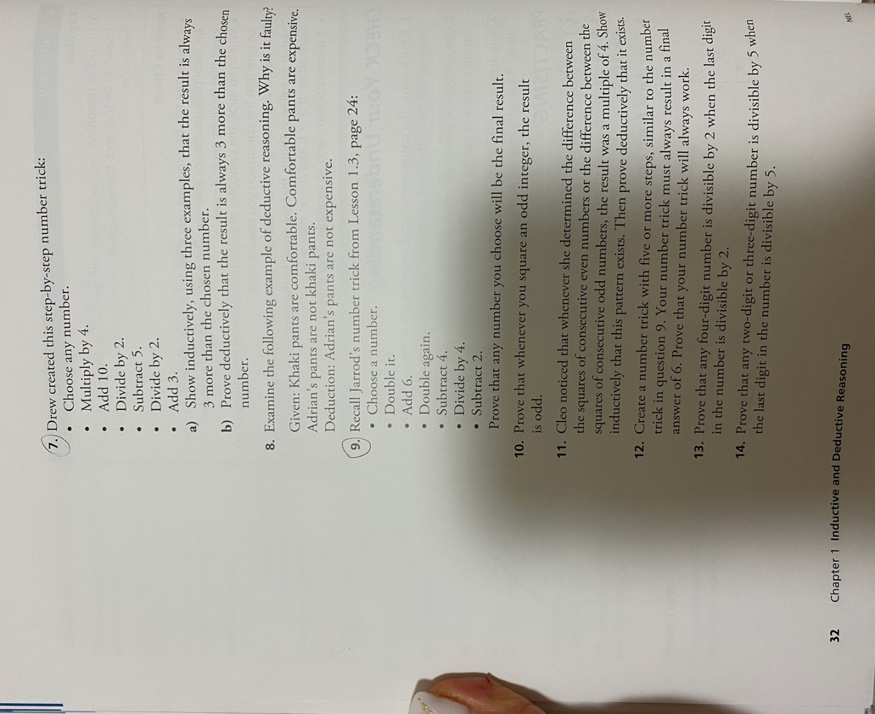
- let the number be 1
1*4=4
4+10=14
14/2=7
7-5=2
2/2=1
1+3=4
4>1
Let the other number be 2
2*4=8
8+10=18
18/2=9
9-5=4
4/2=2
2+3=5
5>2
Finally let the other number be 3
3*4=12
12+10=22
22/2=11
11-5=6
6/2=3
3+3=6
6>3
- proof
Choose any number: let the number be n
Multiply by 4: 4n
Add 10: 4n +10
Divide by 2: 2n + 5
Subtract 5: 2n
Divide by 2: n
Add 3: n+3

9
Choose any number: let the number be n
Double it: 2n
Add 6: 2n + 6
Double again: 4n +12
Subtract 4: 4n + 8
Divide by 4: n + 2
Subtract 2: n

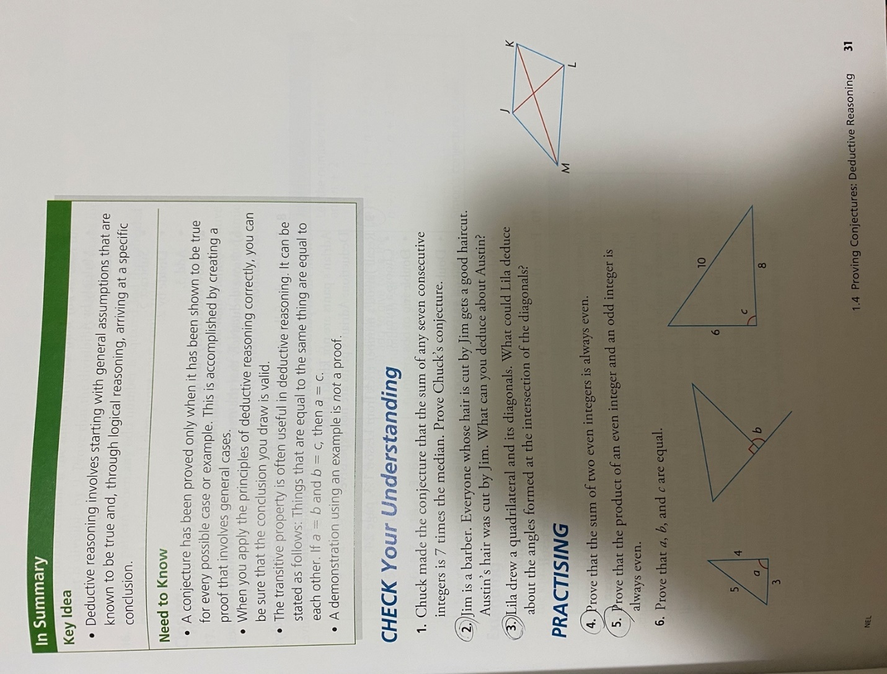
5. Austin assumes that if Jim cuts his hair, he will have a good haircut. This is because, he probably has many of the people whose hair have been cut by Jim are good.
3.
Lila could deduce that the angles formed at the intersection of the diagonals are:
They bisect each other at 90 degrees.
The opposite angles are equal
The angles at the intersection on the same straight line add up to 180 degrees
The total angles at the intersection add up to 360 degrees.
4. proof of the sum of two integers is even
The sum of two even integers can be written as 2b+2y= 2(b+y), where be and y are integers, so (b+y) is an integer and 2 (b+y) is divisible by 2 hence it is an even number.
5 proof of the product of an even integer and an odd integer is always even
Let x and y be integers
Let x be even and y be odd
There exists integer a so that x= 2a
And integer b so that y = 2b+1
If x*y is even, there exist integer q such that x*y= 2q
We have x*y= (2a) (2b+1) =2q
Therefore, x*y is even

